1. Click on the site https://code.visualstudio.com and then click on download for windows.

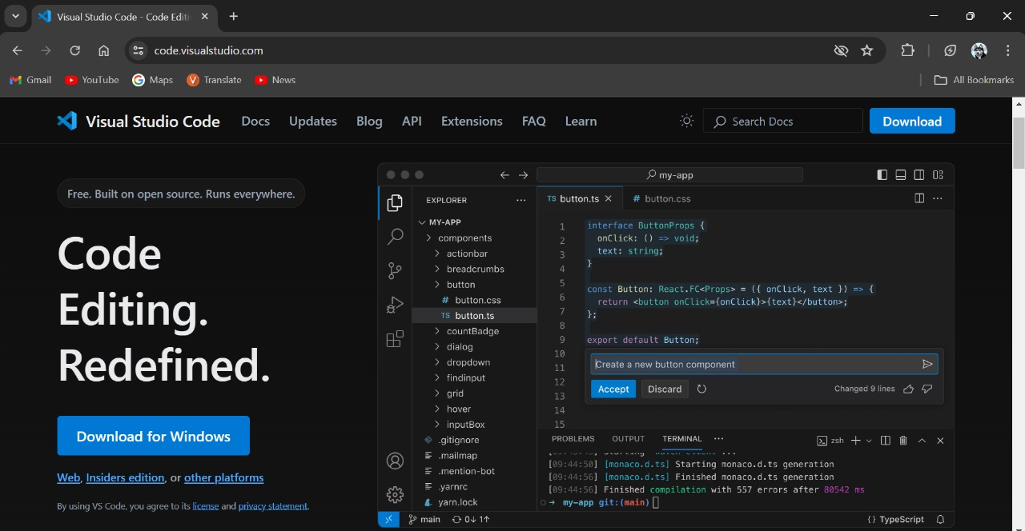

2. Now, your vs code will start downloading. Then click on the recent downloaded file in downloads tab.

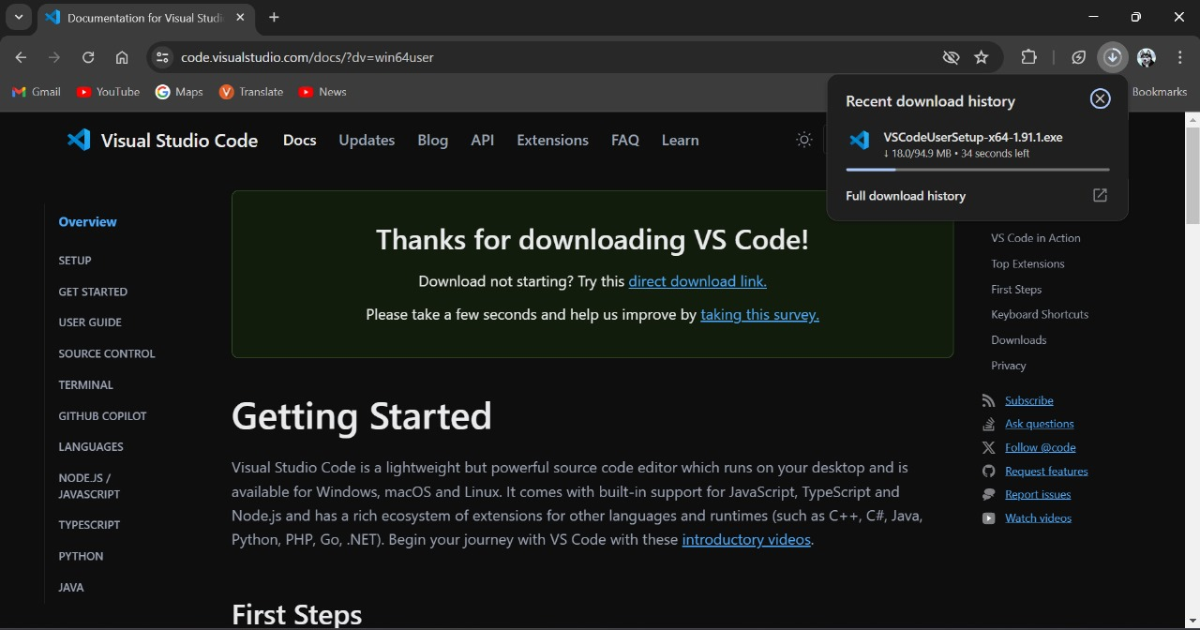

3. Pop up window will appear , click on “I accept the agreement”. And click on next.

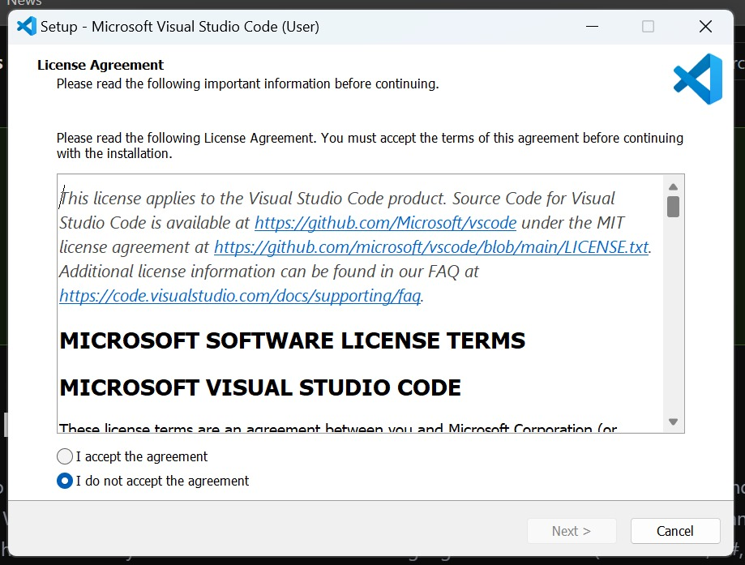

4. Now the setup installs vs code on your computer.

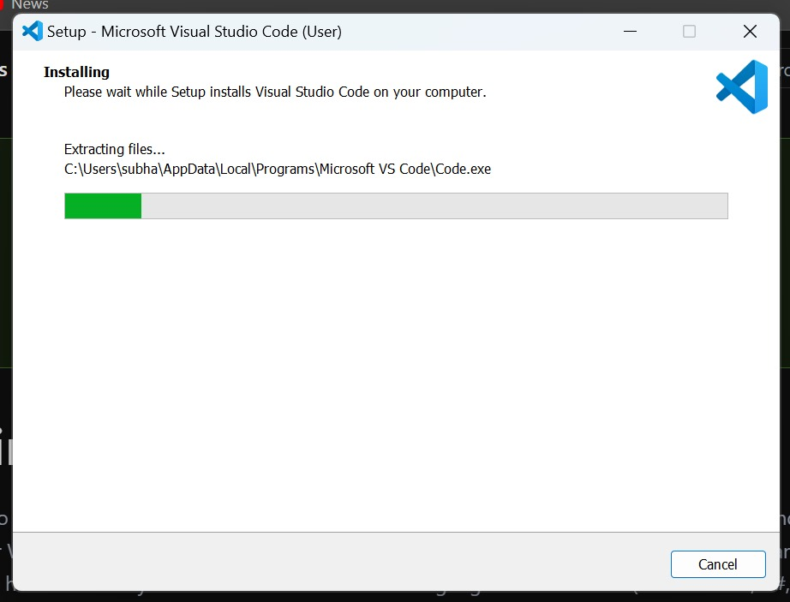

5.As now your vs code is installed, open it and install its other extensions like coderunner and C/C++ in order to run the code.

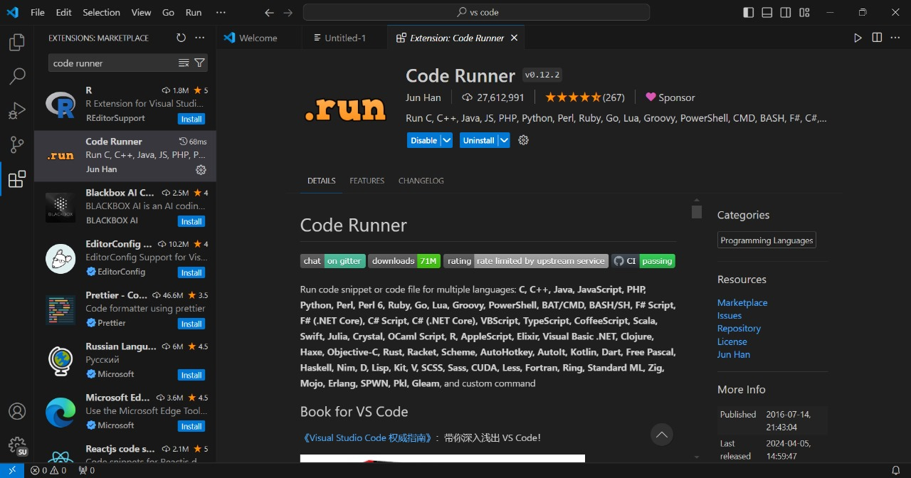

6.Now download MinGW which will compile your code. Site- MinGW - Minimalist GNU for Windows download ,(SourceForge.net).

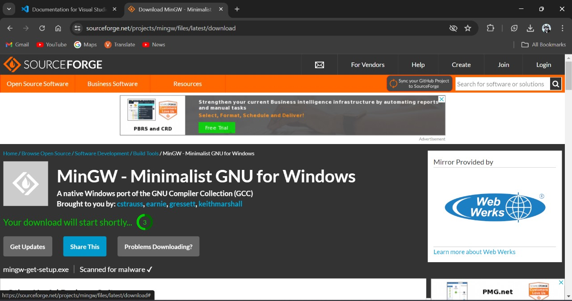

7.A pop up window will appear for the installation of MinGW. Click on install.

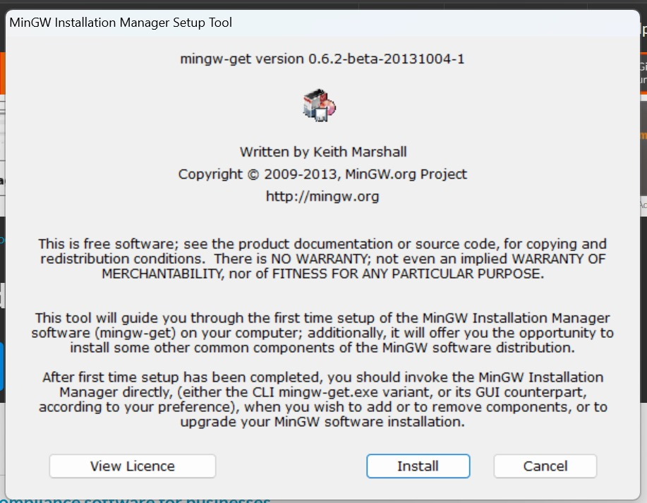

8.After this, various packages will appear. Tick all the required boxes you need for the c and c++ language.

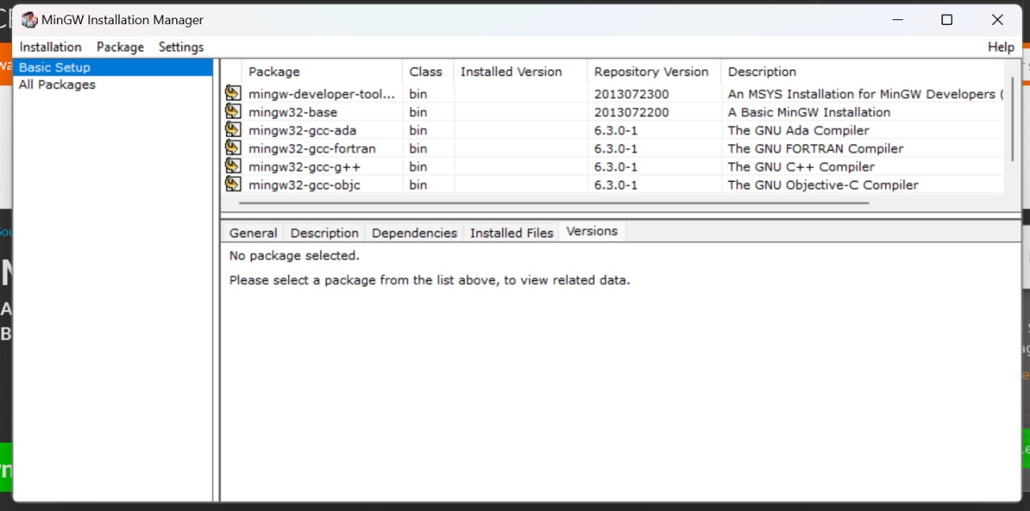

9.Click on apply. Now MinGW is installed.

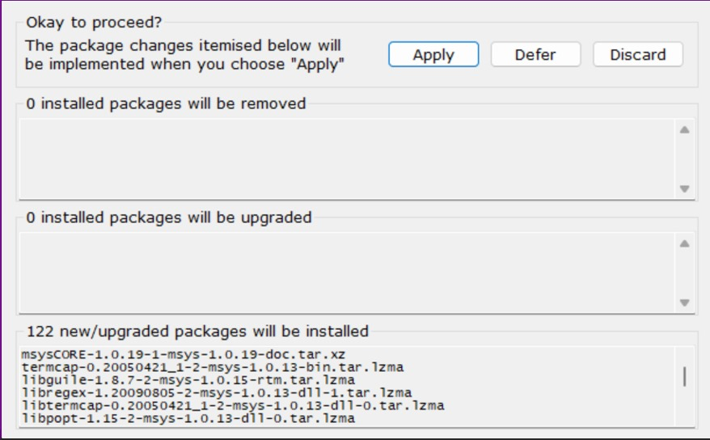

10.After this go to THIS PC click on ‘ Advanced System Settings’. A pop up window will appear, then go to ‘Environmental Variables’.

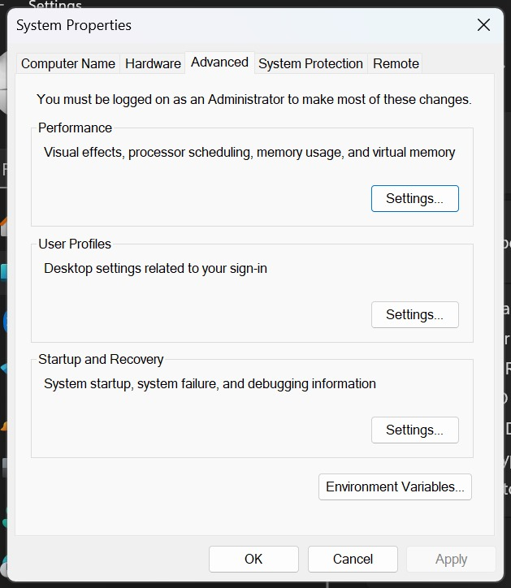

11.A pop-up window will appear. Click on new tab and add the link of the location of MingGW in THIS PC (in bin).And click on OK. Your Visual Studio Code is ready for use.

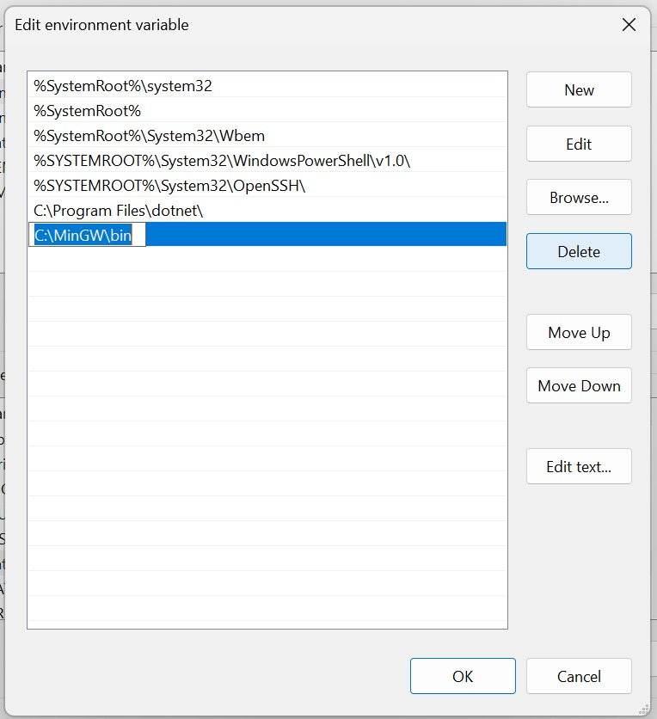

12.Write a small program say to check if the program Runs or not.

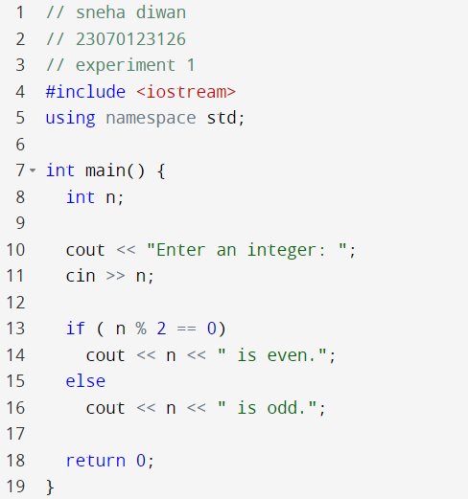

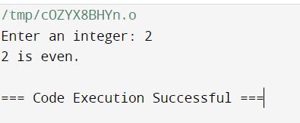

EXP 1 Write a C++ program to print HELLO WORLD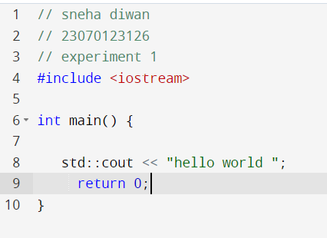

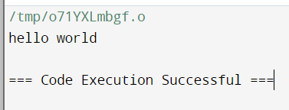

EXP 2 Write a C++ program to print the sum of two numbers.

